**MULTI THREADING:**

1. **INTRODUCTION**
2. **HOW MANY WAYS WE CAN CREATE A THREAD IN JAVA**
3. **GETTING AND SETTING THE THREAD NAME.**
4. **THREAD PRIORITIES**
5. **HOW TO PREVENT THREAD EXECUTION BY JOIN, SLEEP, YIELD METHODS.**
6. **SYNCHRONIZATION**
7. **INTER THREAD COMMUNICATION.**
8. **DAEMON THREADS**
9. **DEADLOCKS AND ENHANCEMENTS IN MULTITHREADING.**

**1) INTRODUCTION:**

* MultiTasking is nothing but executing the multiple independent tasks simultaneously.
* In Java MultiTasking is divided into two types.
  + Process Based MultiTasking.
  + Thread Based MultiTasking.
* Process-Based Multi-Tasking: Executing the multiple independent tasks simultaneously where each task is a separate program is called Process-Based Multi-Tasking. Process-Based Multi-Tasking is applicable in the OS.
* Thread-Based Multi-Tasking: This multi-tasking is applicable at the programmer level. Executing the multiple independent tasks simultaneously where each task is a part of the single program is called Thread-Based Multi-Tasking.
* Applications of the Thread-Based Multi-Tasking:
  + MultiMedia Applications.
  + Video Games.
  + Development in the Web Servers and the Application Servers.
  + Animations.
* Advantages of the Thread-Based Multi-Tasking:
  + Increase in the Performance of execution.
  + Efficient Memory Management.
  + Context Switching between the Threads is possible.
  + Threads share the common memory location.

**2) HOW MANY WAYS WE CAN CREATE A THREAD IN JAVA:**

**Thread:** Thread has lot of definitions below are few valid:

* A Thread is nothing but the flow of execution.
* A Thread is nothing but the light weight process.
* A Thread is nothing but the independent job.
* There are two ways in which we can define a Thread in Java.
  + Extending the Thread class.
  + Implementing the Runnable Interface.
* **EXTENDING THE THREAD CLASS:**

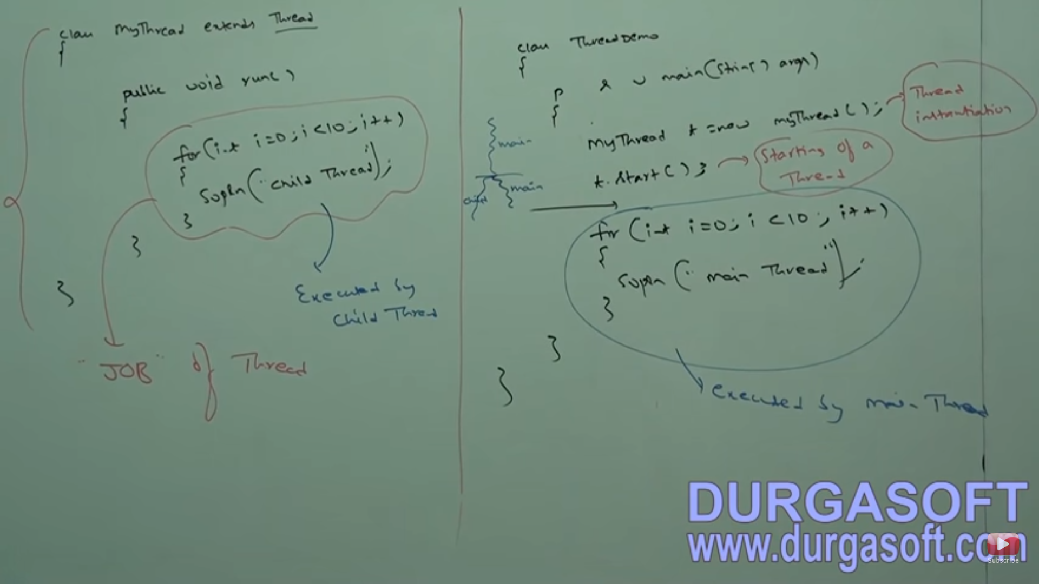

* Please refer your project DefiningThreadInJava.java for how to define the Thread in Java by extending the Thread class.
* After extending the Thread class we have to override the run() of Thread class. The code inside the run() is the Job of the Thread.
* The whole class where we extend the Thread class is Defining a Thread.
* In a java program in general we will have only thread i.e. main thread and main thread in turn can create the child threads.
* When we call start() of the Thread class then a thread will be started and internally main thread and child will execute simultaneously and increases the performance of the application.
* In the above Program main thread starts the child thread. If the jobs are independent then only we should go for the multi-threading.
* main() will be executed by the main thread.

**Case 1: Thread Scheduler:**

* Thread Scheduler is a part of the JVM.
* The role of the Thread Scheduler is to schedule the Threads i.e. If multiple Threads are waiting for the execution Thread Scheduler decides which Thread has to execute based on the Algorithms followed by the JVM like Round Robin, Shortest Job First, Time Slicing.
* Algorithms will vary from JVM to JVM and hence we cannot expect the exact output when we are working with Multi-Threaded Applications.
* We can get several possible outputs when we are running the Application each and every time.
* Below are the possible outputs for the program u have written.

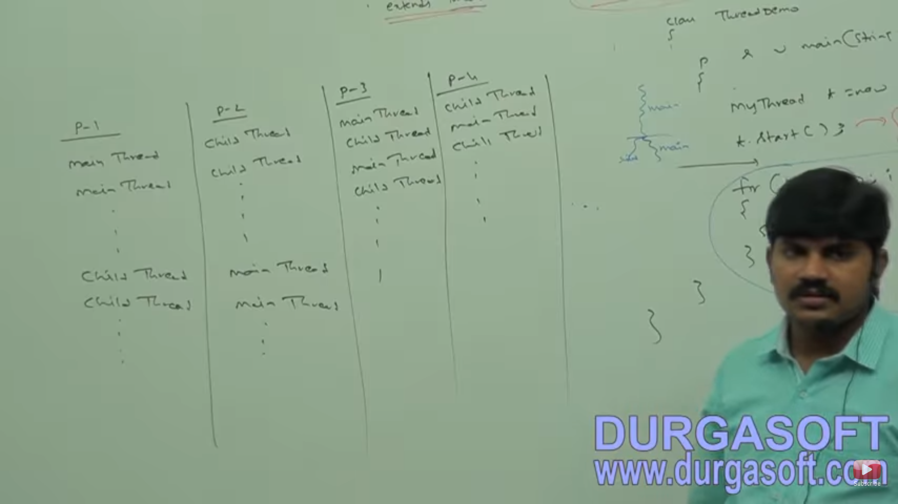

**Case 2: What is the difference between t.start() and t.run().**

* When we call t.start() a separate Thread will be created by main thread and Thread class start() is responsible for executing our Child Class run() and exact output cannot be determined here since we have two threads.
* When we call t.run() directly a separate thread will not be created by the main thread and it will be treated as normal method call and main thread will execute the run() of child thread and in this case exact output can be achieved but the performance factor we cannot achieve since we don’t have multiple threads. The below complete output is produced by the main thread only. Refer CallRunMethodDirectly.java

*ChildThread*

*ChildThread*

*ChildThread*

*ChildThread*

*ChildThread*

*MainThread*

*MainThread*

*MainThread*

*MainThread*

*MainThread*

**Case 3: Importance of Thread class start():**

* There are many activities done by the Thread class start() before it invokes the run() of our ChildThread class. Below are the activities done by the Thread class start().
  + *Registering the current Thread with the Thread Scheduler.*
  + *Adding the current Thread to the Thread Group.*
  + *Calling the run().*
* If we are not going to call the start() then we as a programmer has to do all the above activities in our program which increases the complexity of the program and increases the number of lines of code.
* So start() is considered as the heart of the Multi Threading. Without calling the start() there is no chance of creating a new thread in Java.

**Case 4: Can we overload the run() of Thread class:**

* Yes we can overload the run() of the Thread class. But Thread class start() always calls no-arguments run() only. And other overloaded methods have to be called explicitly. Please refer OverloadingRunMethod.java.

**Case 5: Not Overriding Thread class run():**

* If we don’t override Thread class run() in our program the Thread class run() will be executed and it does not have any implementation. Hence we will get empty output.
* It is highly recommended not to use Multithreading concept if we are not overriding the run() of the Thread class. Refer NotOverridingThreadClassRunMethod.java.

**Case 6: Can we override start() of Thread class.**

* Yes we can override the start() of the Thread class in our class. If we override then a separate thread will not be created and main thread makes a normal call to the overriding start() and overridden run() we have to make explicit call. Refer OverridingStartMethod.java.
* It is not recommended to override the start(). Otherwise not suggested to user Multi-Threading concept.

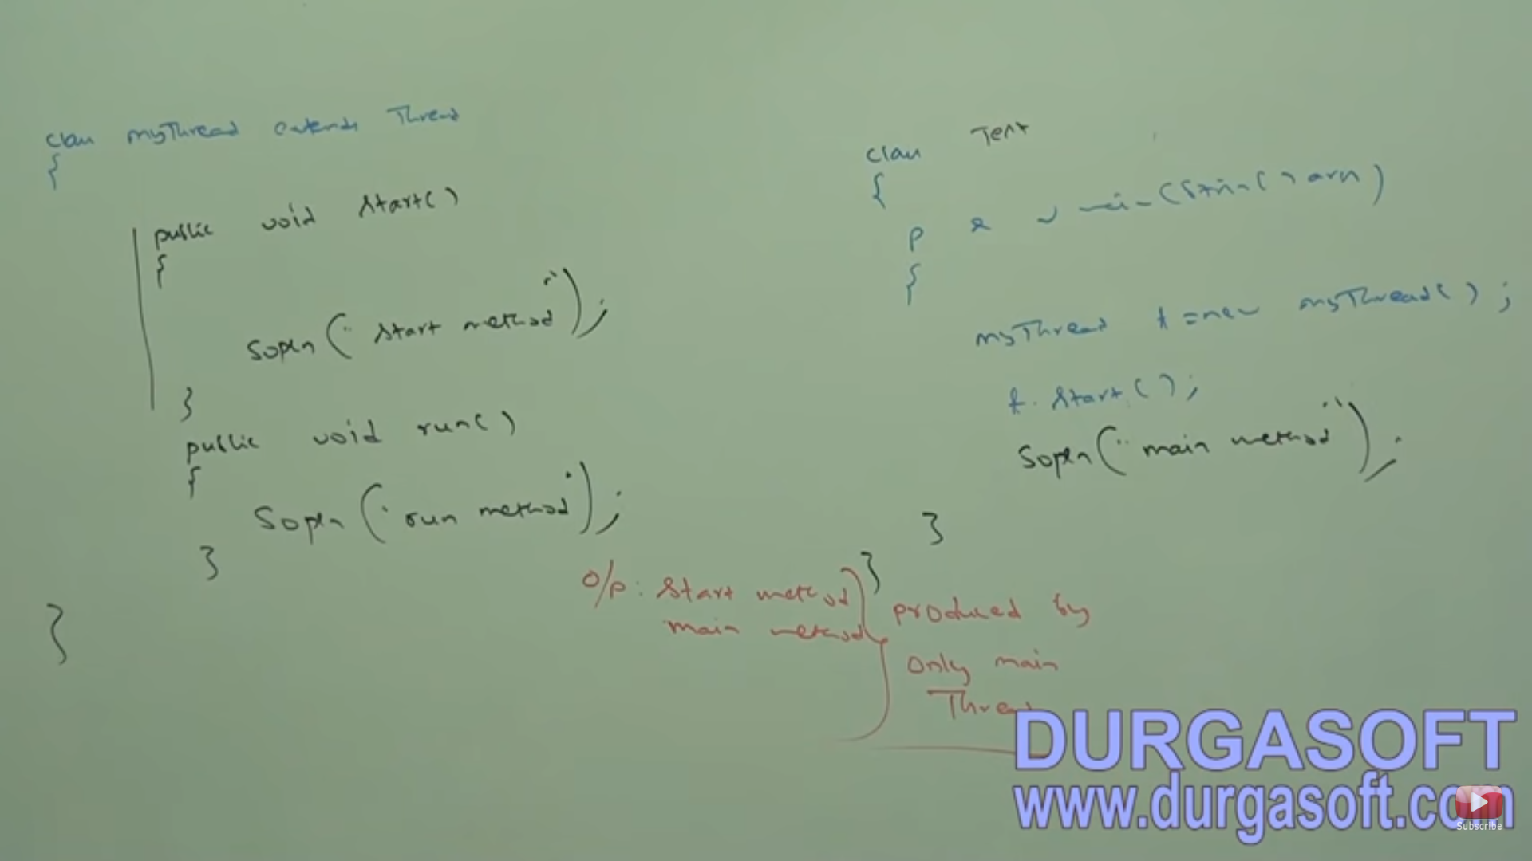

* Super.start() from overriding start() will in turn calls our overriding run().
* After super.start() executes a child thread will be created and multithreading concept is applicable here. And output we cannot predict exactly.

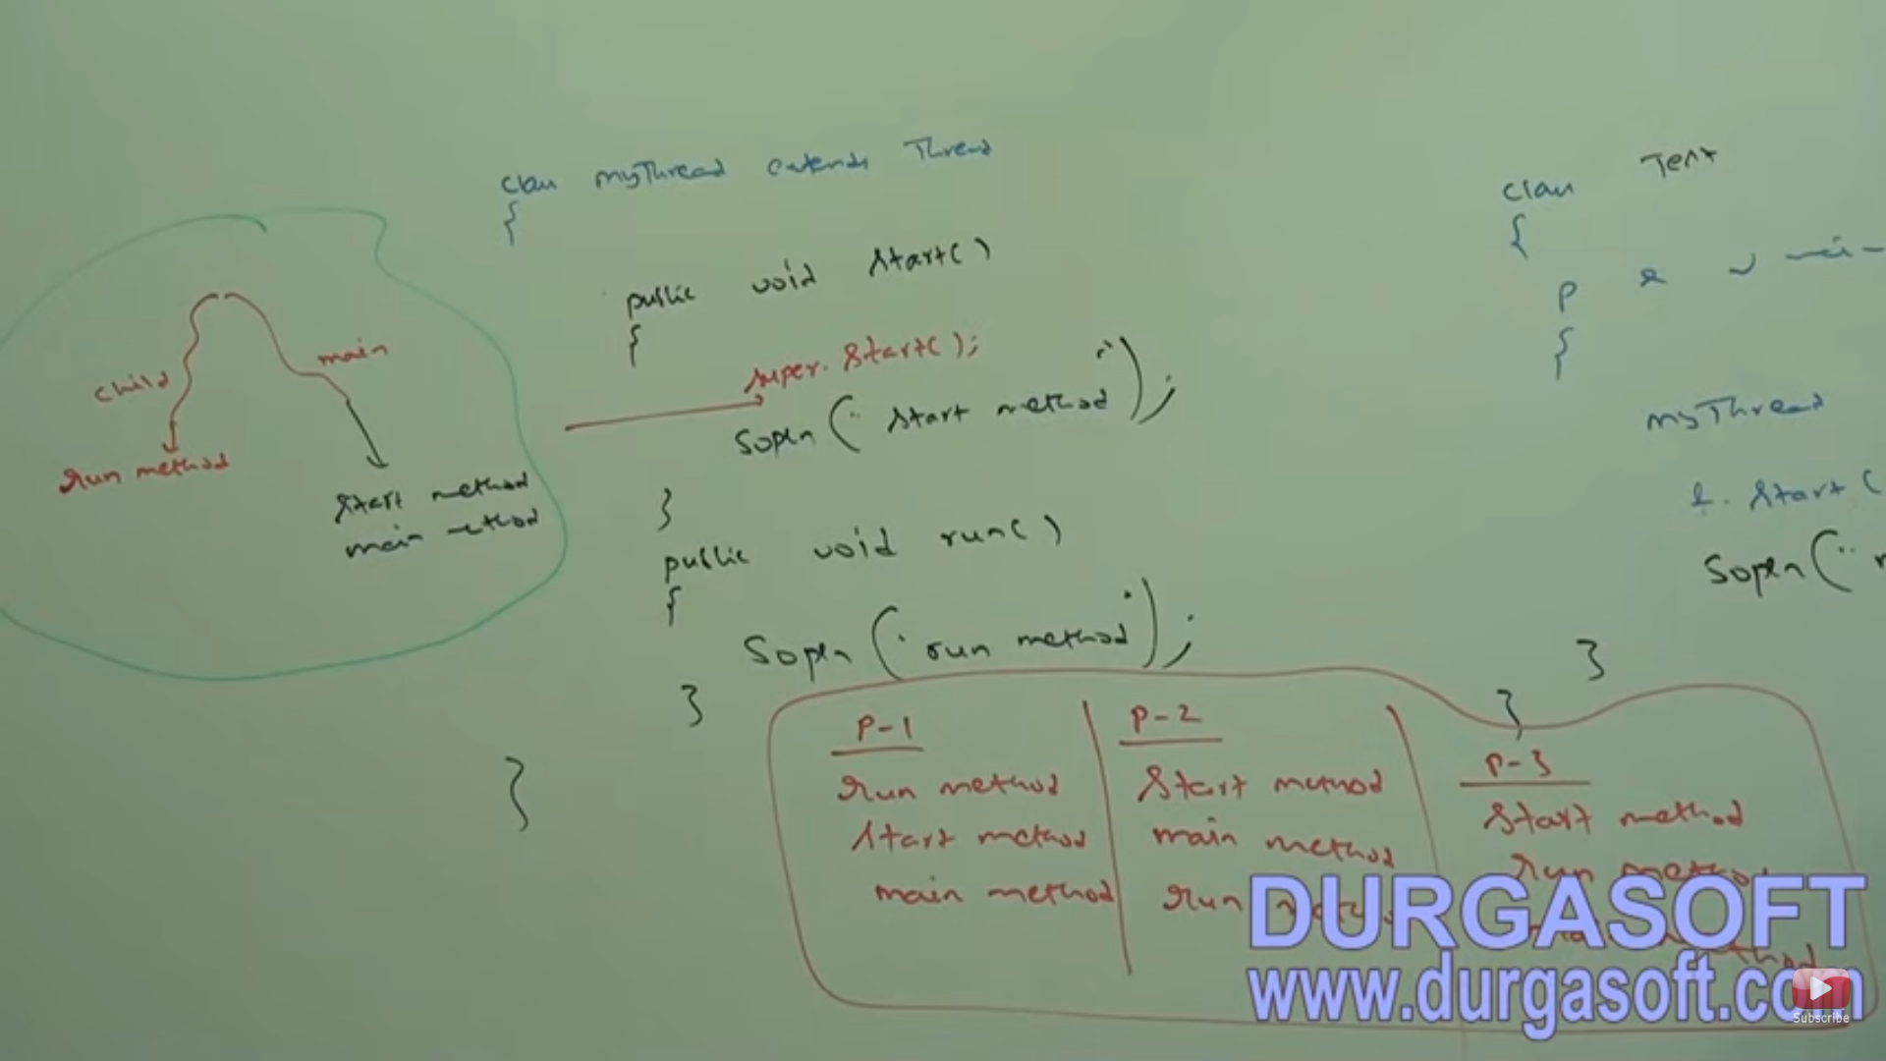

**Case 7: Thread Life Cycle:**

* Below is the simple life cycle of the Thread.
* When we create our Thread class Object then Thread enters into New or Born state.
* When we call t1.start() then thread enters into Runnable state.
* When Thread Schedular allocates Processor for that Thread then it will go Running state.
* Once the run() of our Thread executes then Thread will go to Dead state.

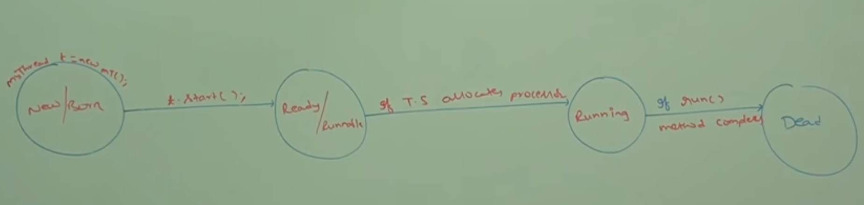

**Case 8: Can we start the same Thread Twice:**

* No once a thread is started we cannot restart the Thread again. If we do so then we will get IllegalThreadStateException.
* Thread will be considered as New state only if thread status is 0 inside start(), once a thread is started the threadstatus will be changed to 2 by JVM. If thread status is not 0 then we will get IllegalThreadStateException.
* Please refer program StartingThreadTwice.java.

**CREATING A THREAD BY IMPLEMENTING RUNNABLE INTERFACE:**

* We can Define Thread by implementing Runnable Interface also.
* Runnable interface is present in the Java.lang package and it has only one method run().
* If we implement the Runnable Interface then we have to provide the implementation for the run() in our class.
* Inorder to execute our class run() we have to create the object of our class and pass as input to the Thread class constructor then our class object will act like Thread class object. Once we call t1.start() then main thread creates child thread which will take care of executing our class run().
* Below is the important case study wrt Runnable Interface.

**MyRunnable r=new MyRunnable();**

**Thread t1=new Thread();**

**Thread t2=new Thread(r);**

**Case 1: t1.start() –** Thread class start() will be executed and it in turn calls Thread class run() with empty implementation. Here a new thread will be created by the main thread.

**Case 2: t1.run();-** Thread class run() will be executed with empty implementation and main thread will not create child thread.

**Case 3: t2.start(); -** Thread class start() will be executed and a separate thread will be created and it in turn calls MyRunnable class run().

**Case 4: t2.run(); -** MyRunnable class run() will be executed and new thread will not be created.

**Case 5: r.start(); -** will give CTE Cannot find the symbol.

**Case 6: r.run();-** MyRunnable class run() will be executed and new thread will not be created by main thread.

* **Between two ways defining a thread which approach is recommended?**
  + Defining a Thread by Implementing Runnable Interface is always recommended as we will not be losing the usage of the inheritance concept, performance improvement and memory utilization. In defining a thread by extending Thread class we cannot actually extend any other class and losing the inheritance concept.
* **Below are the important Thread class Constructors in Java.**

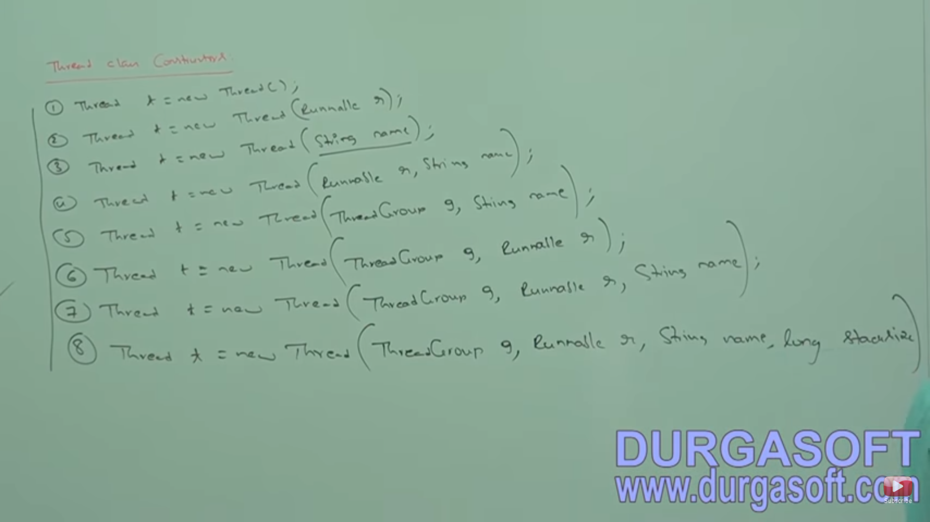

1. Thread t=new Thread();
   1. Creates a Thread class object.
2. Thread t=new Thread(Runnable r);
   1. Creates a Thread class object with the specified job.
3. Thread t=new Thread(String name);
   1. Creates a Thread class object with the specified name.
4. Thread t=new Thread(Runnable r, String name);
   1. Creates a Thread class Object with the specified job and the specified name.
5. Thread t=new Thread(ThreadGroup g, String name );
   1. Creates a Thread class object that belongs to specified ThreadGroup and with the specified name.
6. Thread t=new Thread(ThreadGroup g, Runnable r);
   1. Creates a thread class object with the specified thread group and the specified job.
7. Thread t=new Thread(ThreadGroup g, Runnable r, String name);
   1. Creates a thread class object with the specified threadgroup and specified job with the specified name.
8. Thread t=new Thread(ThreadGroup g, Runnable r, String name, long stackSize);
   1. Creates a thread with the specified stackSize for the runtime stack.

**GETTING AND SETTING THE THREAD NAME.**

* Every Thread in java has some name. JVM by default assigns a name to the thread, if we don’t want the default name then we can explicitly define the name to the Thread with Thread.currentThread().setName(“MyThread”);
* If we want to get the currently executing thread name then we can get with Thread.currentThread().getName().
* Both setName() and getName() are final methods.
* We can get current executing thread by Thread.currentThread();
* Please refer ThreadNames.java for more information.

**4) THREAD PRIORITIES:**

* In Java every thread has some priority, Default priority is assigned by the JVM. If we don’t want the default priority then we can explicitly define the Thread Priority.
* Thread priorities in Java are as below and is available in the Thread class:
  + MIN_PRIORITY: 1
  + NORM_PRIORITY: 5
  + MAX_PRIORITY: 10
  + public final static int MIN_PRIORITY = 1;
  + public final static int NORM_PRIORITY = 5;
  + public final static int MAX_PRIORITY = 10;
* ***Thread Scheduler uses the Thread Priorities while allocating processor. Thread with high priority will get a chance first for execution.***
* ***If two threads having same priority then it’s up to the Thread Scheduler which thread is going to be executed first. We cannot determine exact order of execution.***
* Thread class has below two methods for setting and getting the Thread priorities explicitly.
  + Public final void setPriority(int p). Allowed values for p are from 1 to 10. If we give any other values as input then we will get IllegalArgumentException Ex: t.setPriority(20).
  + Public final int getPriority(): This methods returns the priority of the thread.
* **The Default priority only for main thread is 5 for all other threads default priority will be inherited from parent thread to child thread. Whatever priority Parent thread has Child thread also will have same priority.**
* Refer ThreadPriorities.java.
* Some Platforms won’t provide support for Thread Priorities. There is nothing wrong in our code implementation. Refer ThreadPriorities2.java.

**5)** **HOW MANY WAYS WE CAN PREVENT THREAD EXECUTION:**

* With the below three methods of Thread class we can prevent the Thread Execution.
  + - yield()
    - join()
    - sleep().
* Yield(): Yield methods causes the currently executing thread to pause for some time if any other threads with same priority or high comes for execution. Otherwise if we get the Threads with less priority or no threads are waiting for execution current thread will continue its execution.
* If multiple threads are waiting with same priority, we cannot predict which thread will be executed. It is completely taken care by the Thread Scheduler.
* The thread which is yielded or paused when it will get a chance again, we cannot predict, it completely depends on the Thread Scheduler.
* Syntax of yield() is public static native void yield().
* If we call yield method, thread will go from the Running to Runnable state. Please see the below diagram for more details.

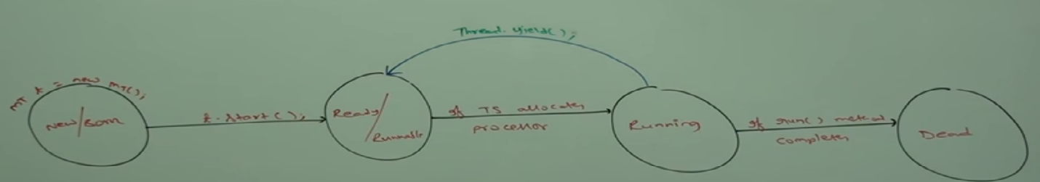

* Refer YieldMethodDemo.java.
* We will be using yield() in the applications where more number of lines of code has to be executed. It is recommended to call yield() in the middle of execution.
* Some platforms won’t provide proper support for yield().
* **Join():** If a thread wants to wait till the completion of the another thread then we have to call join(). Suppose if a thread t1 has to wait till the execution of t2 then t1 thread has to execute the join() with t2 object as t2.join(). Once t2 completes t1 will proceed with its execution.
* **Below is the layman example for join():**



* Suppose we are having three activities for a marriage:
* Venue Fixing(t1), Cards Printing(t2), Cards Distribution(t3). If we want to print cards then venue has to be fixed. Here t2 has to wait till the completion of the t1. Therefore t2 has to join the thread by calling t1.join(). Same is the case wrt to t3 and t2. Here t3 has to wait till t2 completes its task. Hence t3 has to join the thread by calling t2.join().
* Below is the complete signature of the overloaded join() methods:
  + Public final void join(); -waits till the thread completes execution.
  + Public final void join(long ms); -waits this number of milliseconds.
  + Public final void join(long ms, int ns);- waits this number of milliseconds and this number of nano seconds.
* All the join methods throws InterruptedException which is checked Exception if a joined method is interrupted by other thread.
* Below is the impact of the join() in the Thread Life Cycle.
* If a thread t1 has to wait till t2 completes then t1 has to call t2.join() or any other forms of the join() and the thread t1 goes to Blocked state depends on the join() it has invoked. t1 will come to Runnable state after t2 executes completion or t1 got interrupted or join() time expires.

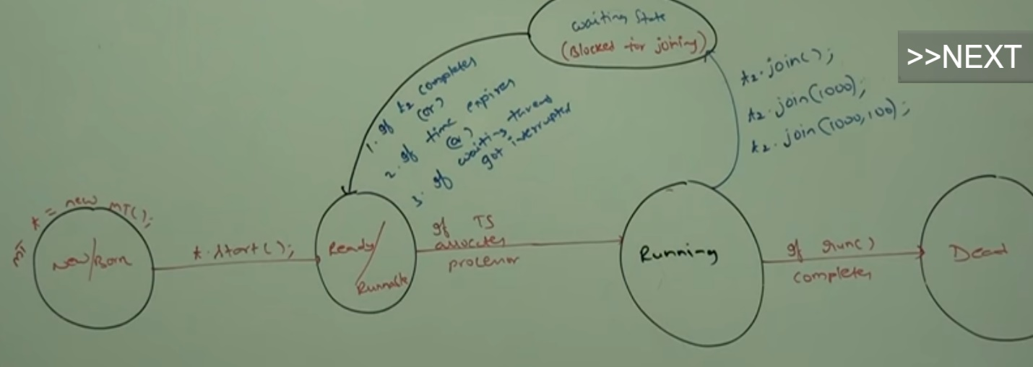

* Refer **ThreadClassJoinMethodDemo.java** for more information on the join().
* We can have both the below scenarios exist:
  + Main Thread waiting for Child Thread to complete its execution.
  + Child Thread waiting for Main Thread to complete its execution.
* Please refer **ThreadClassJoinMethodDemo.java and ThreadClassJoinMethod2.java.**
* If main thread waits for the child thread to complete its execution and child thread waits for main thread to complete its execution. The both threads will wait for each other for ever and it will lead to DeadLock situation.
* Refer DeadLockWithJoin.java
* If a thread calls join() on itself then program will be stuck and it will lead to DeadLock. For example below line of code in main():
  + Thread.currentThread().join();
* In the above scenario Thread.currentThread() will give main thread and that line is also executed by main thread.
* **Sleep():** If we want our thread not to perform any activity for some time then we should use the sleep().
* **Complete signature of sleep():**
  + Public static native void sleep(long mill) throws InterruptedExecption;
  + Public static void sleep(long mill, int ns) throws InterruptedExecption;
* Every sleep() throws InterruptedException, Hence we have to handle InterruptedException in our program. Otherwise we will get CTE.
* Below is the impact of the sleep() in the Thread Life Cycle.
* When we call sleep() Thread will go from Running state to blocked state when we call Thread.sleep(100) or Thread.sleep(1000,100);
* Thread will move from Blocked to Runnable state once the time expires or if the blocked thread is interrupted.

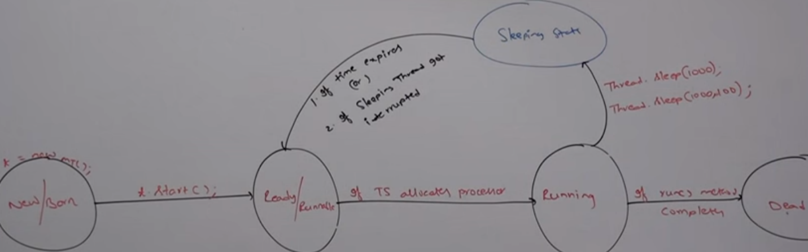

* **Interrupting another thread:**
  + A thread can interrupt a sleeping thread or waiting thread by calling interrupt() of Thread class.
  + If a thread is interrupted then we will get InterruptedException.
  + Please refer InterruptMethodDemo.java.
  + ***If a thread is not in sleeping or waiting state then there is no impact of the interrupt() immediately. Interrupt() will wait till the target thread enters into sleeping or waiting state as soon it entered then that thread will be interrupted and hence in this interrupt() call will not be wasted. This is completely taken care by the JVM.
  + ***Only one scenario where interrupt() call gets wasted is if the target thread never gets into sleeping or waiting state in its life time then interrupt() will get wasted.
  + Refer InterruptMethodDemo2.java for more details on the Thread interruption and wasting the interrupt call.
* **COMPARISON BETWEEN YIELD, JOIN AND SLEEP:**

|  |  |  |  |
| --- | --- | --- | --- |
| **Property** | **Yield()** | **Join()** | **Sleep()** |
| Definition | If a thread wanted to pause for some time when the thread of same priority or with high priority comes for execution then we will go for yield() | If a thread wants to wait till the completion of the other thread then we can use join() | If a thread wants to pause its execution for some time then we have to go for the sleep() |
| Is it overloaded | No | Yes | Yes |
| Is it final method | No | Yes | No |
| Is it native | Yes | No | Yes-sleep(long millis)  No-sleep(long millis, int ns) |
| Does it throws InterruptedException | No | Yes | Yes |
| Is it static | Yes | No | Yes |

**SYNCHRONIZATION:**

* What is the need for synchronization in java? Suppose if multiple threads are operating on the same java object simultaneously then there is high chance of Data Inconsistency problem. To resolve this type of problems synchronization came into picture.
* Real time examples where we will face Data Inconsistency problems are like in the bus reservation system where multiple requests for same seat booking can come at same time which can lead to Data Inconsistency problem.
* Synchronized keyword is only applicable for methods and blocks but not for classes and variables.
* ADV: If we declare a method or block as synchronized then only one thread will be allowed to execute a particular method or block on the given object. Hence we can resolve the data inconsistency problem.
* DISADV: Synchronized keyword reduces the performance of our application. Until and unless there is requirement, we should not use the Synchronized keyword.
* ***Internally synchronization is implemented based on the lock concept. Every object in java is having a unique lock. If thread t1 comes for executing synchronized m1() then JVM assigns the lock to the t1 thread and during the execution of t1 thread if t2 comes then t2 thread has to wait till the execution of the t1 as JVM will not handover lock to t2. This is how synchronization works in Java.***
* **Whenever we are using synchronized keyword then only lock concept will come into picture.**
* If a thread wants to execute synchronized method on the given object first it has to get lock of that object, once thread got lock then it is allowed to execute any synchronized method on the object. Once method execution completes thread automatically releases the lock. Acquiring and releasing lock internally takes care by JVM and programmer not responsible for this activity.
* ****While a thread t1 is executing the synchronized method in the class X below then it will acquire the lock of the Object X, if threads t2 and t3 came for executing m1() and m2() then they will not get a chance since at a time on a locked object only one synchronized method is allowed to execute. And hence t2 and t3 has to be in waiting state till t1 completes its execution and release object x lock. In the below t4 came for executing m3() which is non-synchronized then it will be allowed to execute simultaneously. Remaining threads are allowed to execute non-synchronized methods simultaneously.
* Lock concept is implemented based on object not based on method.

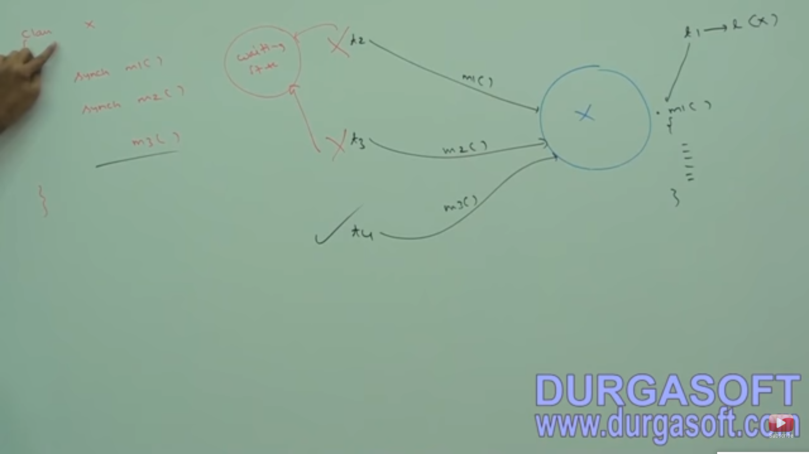

* In Java every object has two areas Synchronized Area where we will be performing all the update, delete and add operations and this area is accessed by only one thread at time and which changes the state of the object.
* Another area is non-synchronized area where this area can be accessed by multiple threads at a time like read operation which does not change the state of the object.
* So when we are coding we should be very careful about the above two areas. Synchronized Area has to be declared with synchronized keyword where we have to perform the change to the object state. And Non-Synchronized area where we have to perform the only read operations has to be in non-synchronized methods. Please see below diagram for more details.



* For Example if we are using the ReservationSystem class then we will have two functionalities i.e. checkAvailability() of seats and bookingTicket(). Here checking availability of seats is read operation and can be performed by any number of threads at a time. But bookingTicket() has to be done by only one person at a time and hence we have to use synchronized key word for that.
* Please refer what are the problems we face when we don’t use synchronization when required in ProblemWithOutSynchronization.java.
* Please refer ResolvingDataInconsistencyProblemWithSynchronization.java for resolving DataInconsistency problem with synchronized keyword. If multiple threads are operating on the same java object then lock concept comes into picture here.

**Case Study:**

* If multiple threads are operating on the multiple objects then synchronization concept is not required as each thread will get the lock of its corresponding object and its lock hence all threads execute simultaneously. Synchronization is required only if multiple threads are trying to access the same object simultaneously.
* Please MultipleThreadsMultipleObjects.java and below diagram for more information on this.

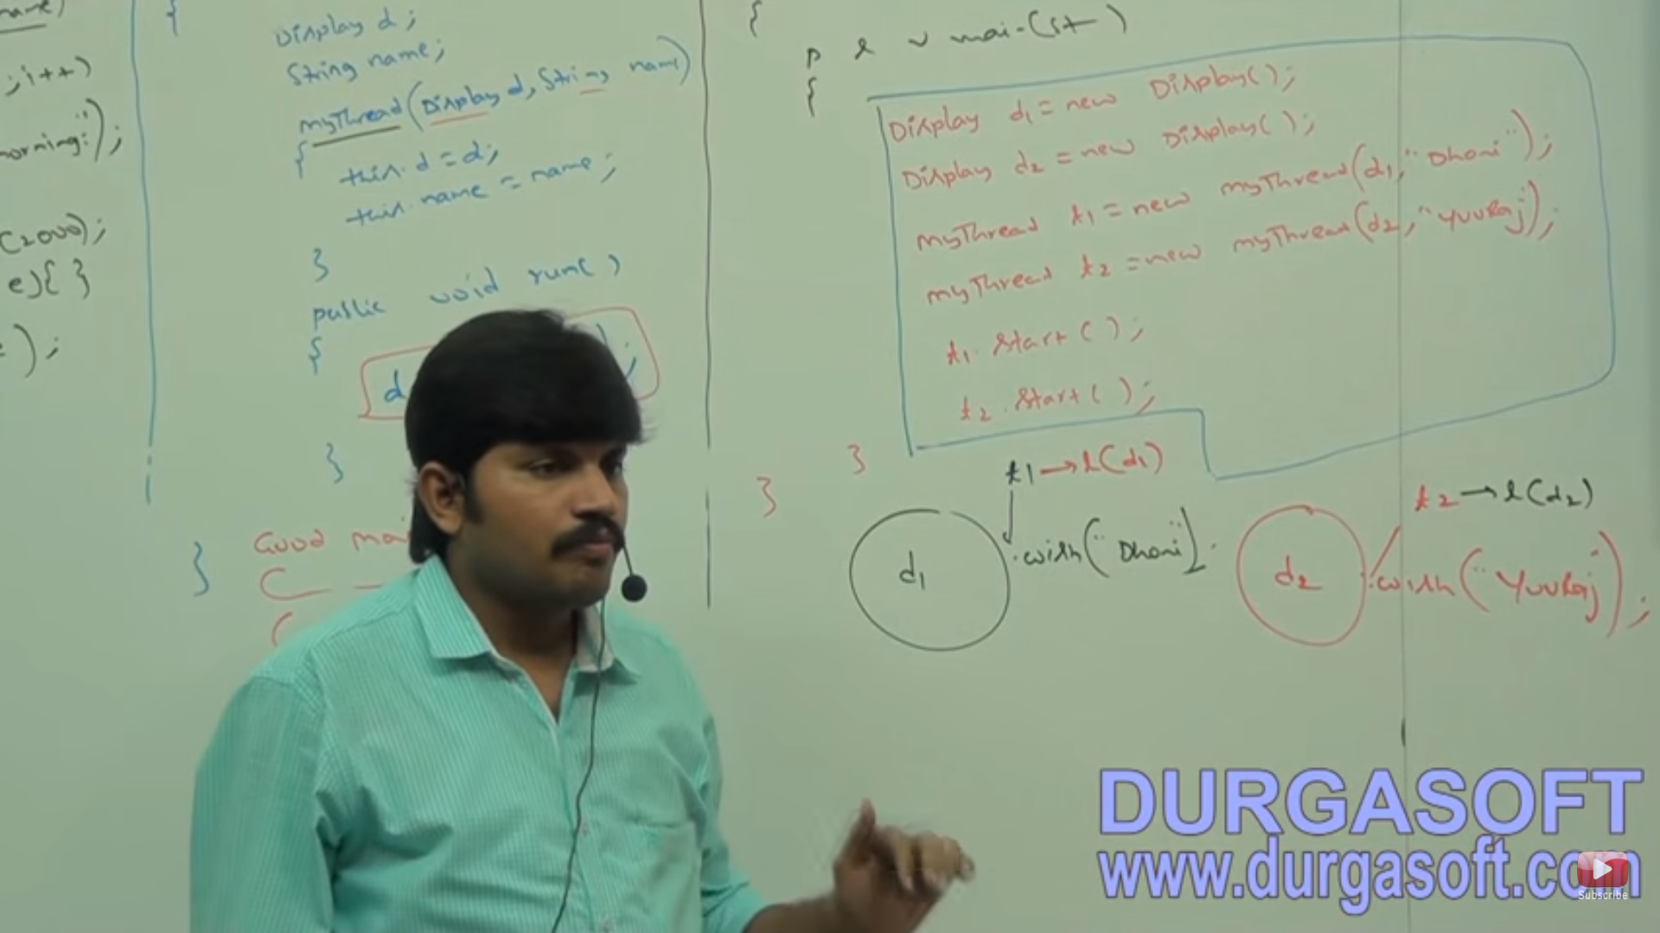

**CLASS LEVEL LOCK:**

* Every class in java has a unique lock which is called class level lock.
* When class level lock is required? If a thread wants to execute static synchronized method then that thread requires Class Level lock once static synchronized method is executed automatically class level lock will be released.
* Once a thread gets the class level lock till it completes its execution no other thread can get the class level lock.
* Refer StaticSynchronizedMethod.java for more details.
* In this Scenario we will get the Regular Output only.
* Please go through the below pic for more details on the Class Level Lock and Object Level Lock.
* **Class Level Lock and Object Level Lock both are different.**

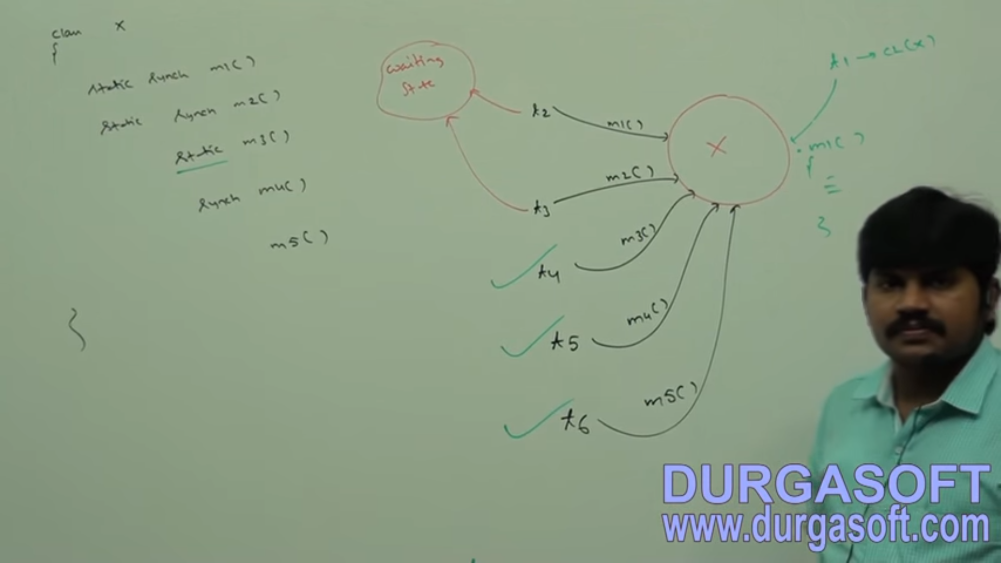

* In the above image we have 5 methods of different kinds.
* Suppose t1 thread came to m1() since Class Level Lock is Available JVM assigns the Class level lock to t1 thread and it will execute m1().
* Now t2 came to execute m1(), since Class level lock is available with t1 t2 has to wait till the class level lock is released.
* Now t3 came to execute m2() static synchronized method since class level lock is with t1, t3 also has to wait till class level lock on class X gets released. Therefore, at a time only one thread can access the one static synchronized method and other cannot access any of the static synchronized methods of that class.
* Now t4 came to execute static m3() since it is normal static method it can execute simultaneously.
* Now t5 came to execute synchronized m4(), since Object level lock is free t5 can get the Object level local and proceed with the execution of the m4() simultaneously.
* Now t6 came to execute the instance m5(), since it’s a normal instance method it can execute that simultaneously.
* Please refer SynchronizationExample2.java for more details about the synchronization.

**SYNCHRONIZED BLOCK IN MULTITHREADING:**

* Suppose if in a method of 10k lines if we need synchronization only for some few lines of code then we can declare those lines of code in the synchronized block so that waiting time of the threads is going to reduce tremendously which in turn increases the performance of the program.
* So, if we require very few lines of code synchronization, synchronized block is preferred over the synchronized method.
* We can declare synchronized block as follows:

1. To get the lock of Current Object:
   1. Synchronized(this){

----------------

-----------------

} The shaded area will be allowed to execute if and only if thread gets the lock of the current object.

1. To get lock of Particular object p:
   1. Synchronized(p){

--------------------

--------------------

} The shaded area will be allowed to execute if and only if thread gets the lock of the object p.

1. To get the Class level lock:
   1. Synchronized(Display.class) {

---------------------

----------------------

} The shaded area will be allowed to execute if and only if thread gets the lock of the Specified Class.

Below diagram explains more about the declaration of the Synchronized block:

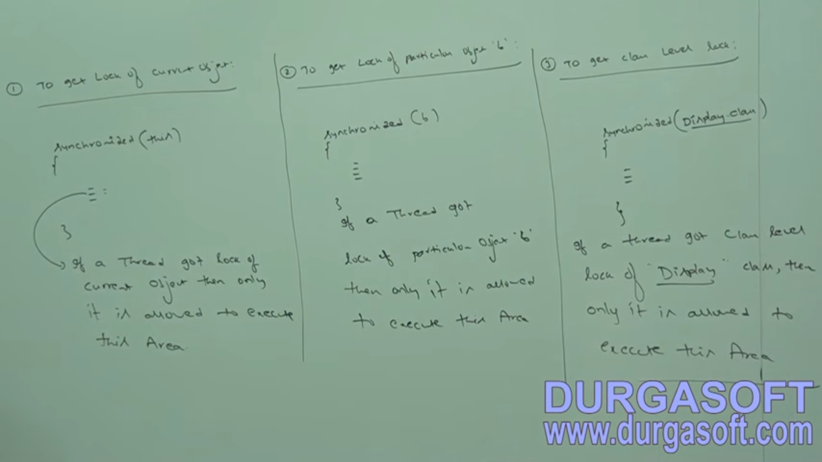

* If multiple threads are accessing multiple objects then synchronization is not required. If multiple threads are accessing same object then synchronization will come into picture.
* We have only two types of locks in java Object lock and Class level Lock. Therefore, if we pass any primitive data type as input to the synchronized block, we will get CTE, like not a valid argument to the synchronized block.

Interview Questions about Synchronization:

***1) what is synchronized keyword where we can apply***

***Ans: Synchronized keyword is applicable only for the blocks and methods. Synchronized keyword is used where***

***ever we face data inconsistency.***

***2) Advantage of Synchronized : Data Inconsistency problem can be avoided.***

***3) Disadvantage of synchronized : Performance issue.***

***4) Race Condition: If multiple threads are trying to access a common object, then the situation is called***

***Race Condition. This Race condition can be resolved by synchronization keyword.***

***5) Object Lock: Object lock is used during the synchronization concept and if a thread has to execute the***

***synchronized block or method then it has to get the lock of the particular object, then only that thread***

***can be able to access the synchronized method or block.***

***6) Class level lock: It is applied on the class, these class level locks are applied on the static synch methods.If a thread has to execute the static synchronized method then it has to acquire the class level***

***lock.***

***7) Class level lock is applied on the classes, Object level lock is applied on the objects.***

***8) If a thread is operating on a synchronized method, then any other thread cannot access any other***

***synchronized methods on the particular class.***

***9) How to declare synchronized block to get the lock of the current object : synchronized(this).***

***10) How to declare synchronized block to get the class level lock: synchronized(Display.class).***

***11) Advantage of synchronized block over synchronized method : Performance***

***12) Can a thread acquire multiple locks simultaneously: Yes from different objects refer ThreadAcquringMultipleLocks.java***

***13) Synchronized statement: Statements present inside the synchronized method or block which are executed by***

***only one thread at a time are called synchronized statements.***

**INTER-THREAD COMMUNICATION:**

* Two threads can communicate each other with the help of wait(), notify(), notifyAll() methods which helps in reducing the waiting time of the threads.
* The thread which is expecting update has to call the wait() and it will go to the waiting state.
* The thread which is updating has to call the notify() method and notification has to be sent to the waiting thread so that it will continue its execution.
* ******wait() , notify() and notifyAll() are present in the Object class not in the Thread class.
* ******Why wait(), notify() and notifyAll are present in Object class not in the Thread class? For example if we take start() this is applicable only for the Threads so it is in Thread class, same is the case with join(), sleep(). The thread which is expecting update has to call wait() on a particular object, this particular object can be of any type. The thread providing the update has to call the notify() on the particular object, this particular object can be of any type. Hence a particular thread can call wait() or notify() on any Java Object. If a method is required for all the Java Objects then that methods has to be declared in the Object class.
* To call wait() or notify() or notifyAll() on a particular object by a thread, then that thread should be the owner of that object i.e. thread should acquire the lock of that object.
* Wait(), notify(), notifyAll() can be called only in the synchronized area. If a thread try to access these methods outside synchronized area then we will get IllegalMonitorStateException.
* If a thread t1 calls wait() then t1 releases the lock of that particular object immediately and enters into waiting state. It will not release the lock of the other objects.
* If a thread t2 calls notify() then t2 may or may not release the lock on the particular object as it may perform update after sending notification or update and then send notification and then it may release lock.
* Only in wait(), notify() and notifyAll() object locks will be released not in any other methods. The reason is wait() , notify() and notifyAll() can be called only inside the synchronized area, if a particular thread is not releasing the locks then other threads has to wait till it gets lock.

|  |  |
| --- | --- |
| **Method Name** | **Is Thread releases the Lock** |
| Yield() | No |
| Join() | No |
| Sleep() | No |
| Wait() | Yes |
| Notify() | Yes |
| NotifyAll() | Yes |

Some Important Questions w.r.t wait(), notify() and notifyAll():

* If a thread calls wait() on any object then that thread will go to waiting state without releasing lock –False: It releases lock immediately and enters to waiting state.
* If a thread calls wait() it releases the lock of that object but may not immediately. –False: Releases immediately and enters into waiting state.
* If a thread calls wait() it releases all locks acquired by that thread immediately and enters into waiting state: -False: Releases the lock of only that particular object not all the locks of other objects.
* If a thread calls wait() on any object then that thread releases the lock of that object immediately and enters into waiting state-True.
* If a thread calls notify() on any object then it immediately releases the lock of that object – False: It may or may not release the lock of that object immediately.
* If a thread calls notify() on any object then it releases the lock of that object but may not immediately-True.

**Complete prototype of wait(), notify() and notifyAll():**

* Public final void wait() throws InterruptedException
* Public final native void wait(long ms) throws InterruptedException
* Public final void wait(long ms, int ns) throws InterruptedException
* Public final native void notify()
* Public final native void notifyAll()
* All the wait()’s throw InterruptedException which is checked Exception. So we have to handle this at the CT only other we will get CTE.

**Below is the impact of the wait() in the Thread Life Cycle:**

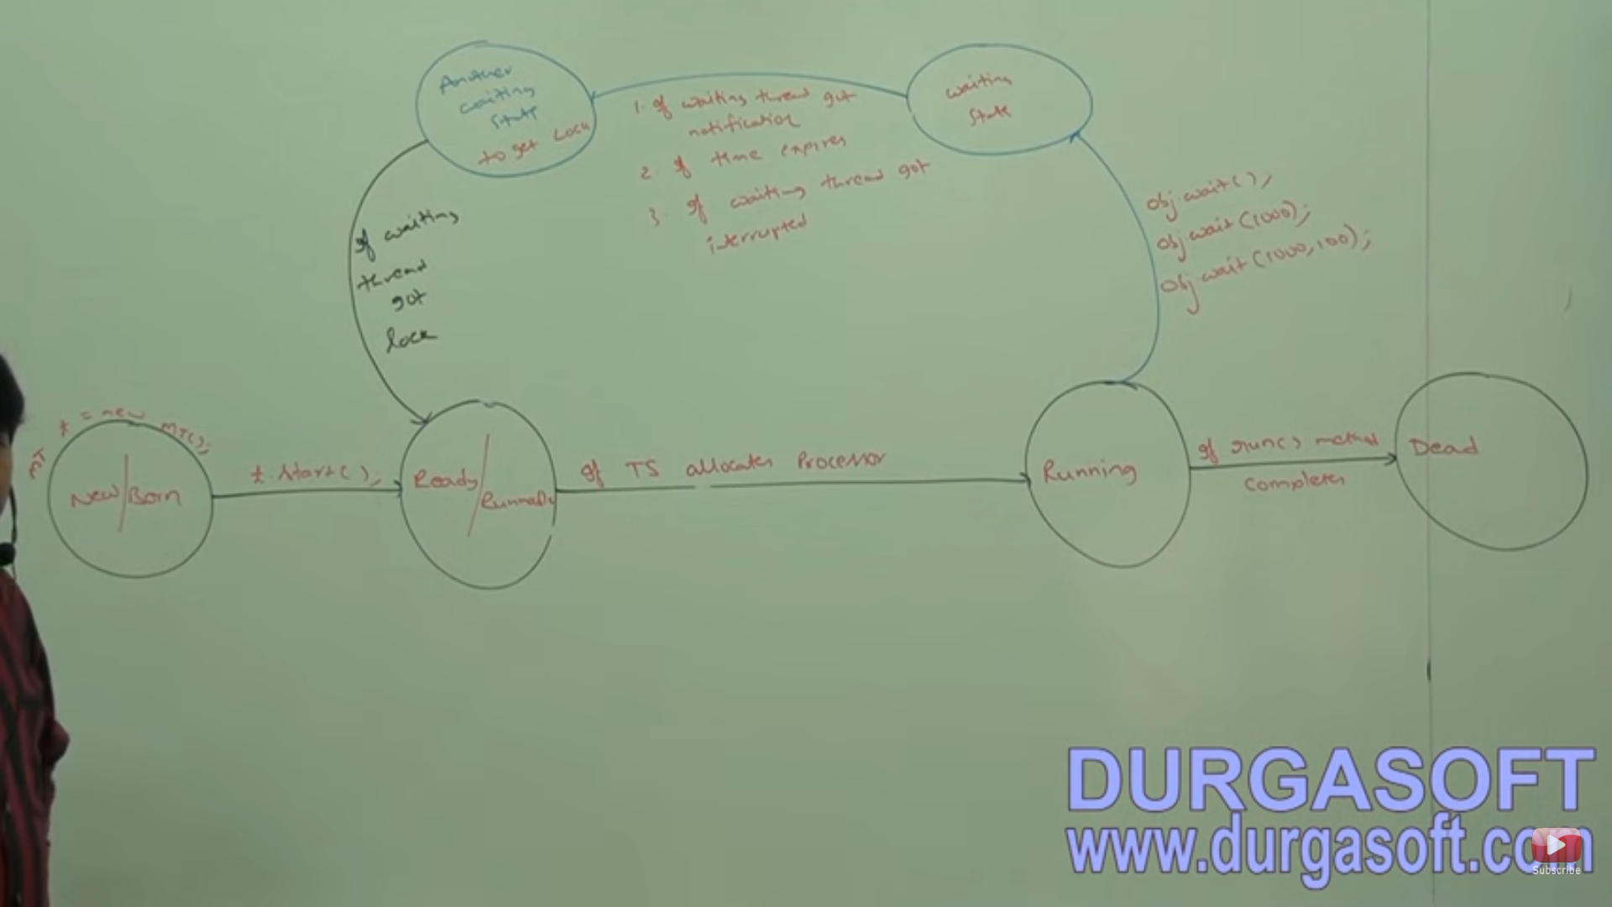

* In the above diagram when wait() is called by a thread by calling wait() or wait(1000) or wait(1000,100) then it will go to waiting state. If the waiting time of the thread expires or it is interrupted or it gets notified then this thread will go to another waiting state for lock. Once it acquires the lock of the object then this thread will go to Runnable state.
* If we call sleep() or join() for the purpose of waiting we may end up in the waiting for the target threads to complete execution or it may complete before the time we specify in the corresponding sleep() or join().
* Therefore it is highly recommended to use wait() for these purposes.

**PRODUCER-CONSUMER PROBLEM:**

* In this problem Producer Thread produces the items to the queue, after producing the items to the queue it will call the notify() and gives notification to the Consumer thread.
* The purpose of the consumer thread is to consume the items from the Queue, if Queue is empty then Consumer thread will call the wait() and goes to waiting state immediately releasing the lock. Otherwise it will consume the items. Please see the below diagram for more details on the Producer-Consumer problem.

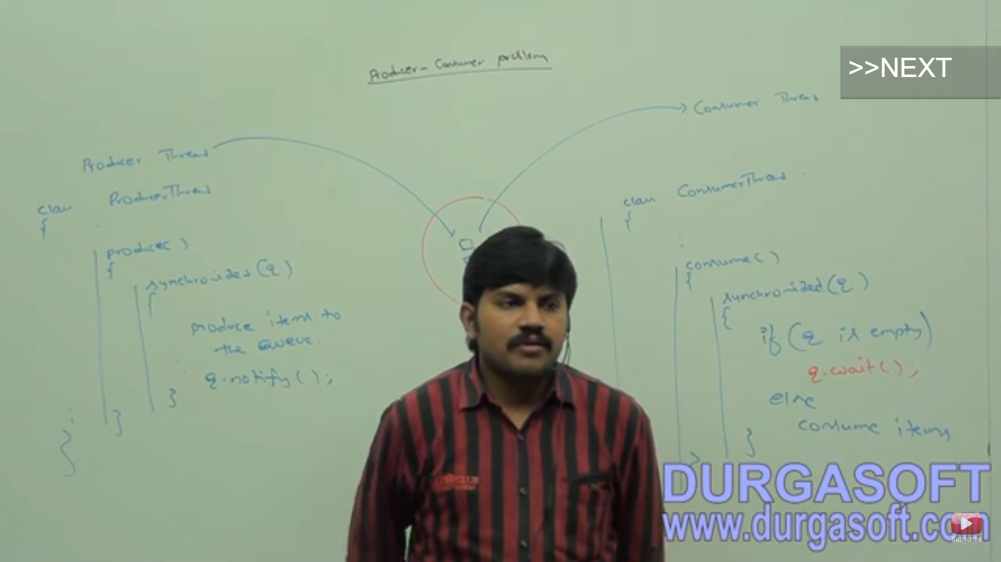

**BELOW ARE THE DIFFERENCES BETWEEN NOTIFY AND NOTIFYALL():**

|  |  |
| --- | --- |
| **Notify()** | **NotifyAll()** |
| Notify() is mainly for the purpose of the notifying a single waiting thread. And at a time notify() can send notification to only one thread. If multiple threads are in waiting state then which thread will be notified is completely depends on the JVM. | We can use notifyAll() for giving notification to all the waiting threads of a particular object. Even though multiple waiting threads of a particular object are notified only one thread will get a chance to execute as each thread requires a lock and only one object lock is available. |

* ****If we are calling a wait() on a particular object then first we should get the lock of that object i.e. if we want to call object o1 wait() then first we should get the lock of the object o1. If we get the lock of the o1 and we are calling o2.wait() then we will get IllegalMonitorStateException. Below demonstrates the same.

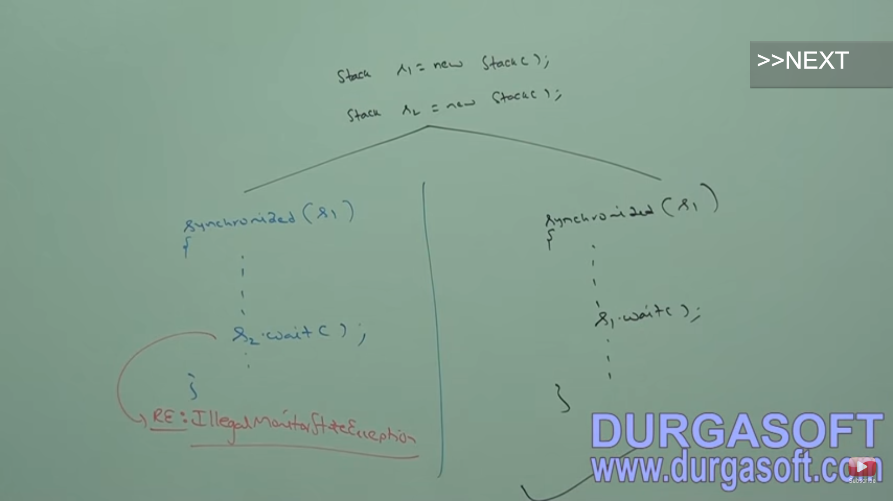

**DEADLOCKS IN MULTITHREADING:**

* When two threads t1 and t2 wait for each other for ever then the situation is called deadlock.
* Synchronized keyword is responsible for the deadlocks. If there is a valid requirement then only use the synchronized keyword otherwise please don’t use the synchronized keyword.
* We cannot do anything if a deadlock occurs, but we can prevent deadlock in many ways.
* Please refer DeadLockWithSynchronized.java.

**DIFFERENCES BETWEEN DEADLOCK AND STARVATION:**

|  |  |
| --- | --- |
| **DEADLOCK** | **STARVATION** |
| If two threads wait for each other for ever then that condition is called deadlock. | If the waiting time of the threads ends at some particular point of time then that condition is called starvation. Suppose a thread of low priority has to wait till the execution of all high priority tasks. |

**DAEMON THREADS:**

* Daemon threads are the threads which run in the background and provide support for the main thread.
* Example of Daemon Threads are:
  + - GARBAGE COLLECTOR.
    - SIGNAL DISPATCHER.
    - ATTACH LISTENER.
* Usually the priority for the Daemon threads are low. But based on the situation JVM increases and decreases the priority of the Daemon threads. For Example if main thread is running and suddenly faced memory issue then at this point of time JVM increases the priority of the Garbage Collector Daemon thread and it removes the unused objects and frees up the memory for the main thread.
* We can check the Daemon nature of the thread by calling isDaemon() of Thread class. And we can set the Daemon nature to a particular thread by calling setDaemon() of Thread class. But the daemon nature has to be set before the thread is started. Otherwise we will get IllegalThreadStateException.
* By default, main thread is non-daemon in nature, for all the other threads daemon nature will be inherited from the parent threads. Suppose if parent thread is Daemon in nature then Child Thread is also Daemon in nature.
* Can we change the Daemon nature of the main thread? No its impossible to change the Daemon nature of the main thread as this thread is started by JVM and if we try to change we will get IllegalThreadStateException.
* Please refer DaemonThreadDemo.java.
* Whenever last non-Daemon thread terminates then all the Daemon threads will be terminated automatically irrespective of its position.
* Please refer DaemonThreadDemo2.java.

**GREEN THREAD:**

* In Java multithreading concept is developed based on the two models:
  + Green Thread Model.
  + Native OS Model.
* **Green Thread Model:** If the life cycle of the thread is completely managed by the JVM without taking support of the underlying OS, then this model is called green thread model. Currently Green Thread Model is deprecated. Only very few OS supports Green Thread Model i.e. SUN SOLARIS.
* **Native OS Model:** If the life cycle of a thread is managed by the JVM and the underlying OS then that type of model is called Native OS Model. Windows supports Native OS Model.

**HOW TO STOP A THREAD IN JAVA:**

* In Multithreading concept if we call stop() then the thread will be stopped immediately and will be entered into the dead state. However it is not recommended to use the stop() as it is deprecated and can cause many problems if we use this method.
* Please refer StopMethodDemo.java

**HOW TO SUSPEND AND RESUME A THREAD:**

* If we call suspend () on a particular thread then that thread will enter into the suspend state. If we call the resume() of Thread class on that particular thread then suspended thread can resume its activities. However suspend() and resume() are deprecated and not recommended to use. Why suspend() and resume() are deprecated because they are deadlock prone.
* Below is the complete life cycle of a thread for all the methods:

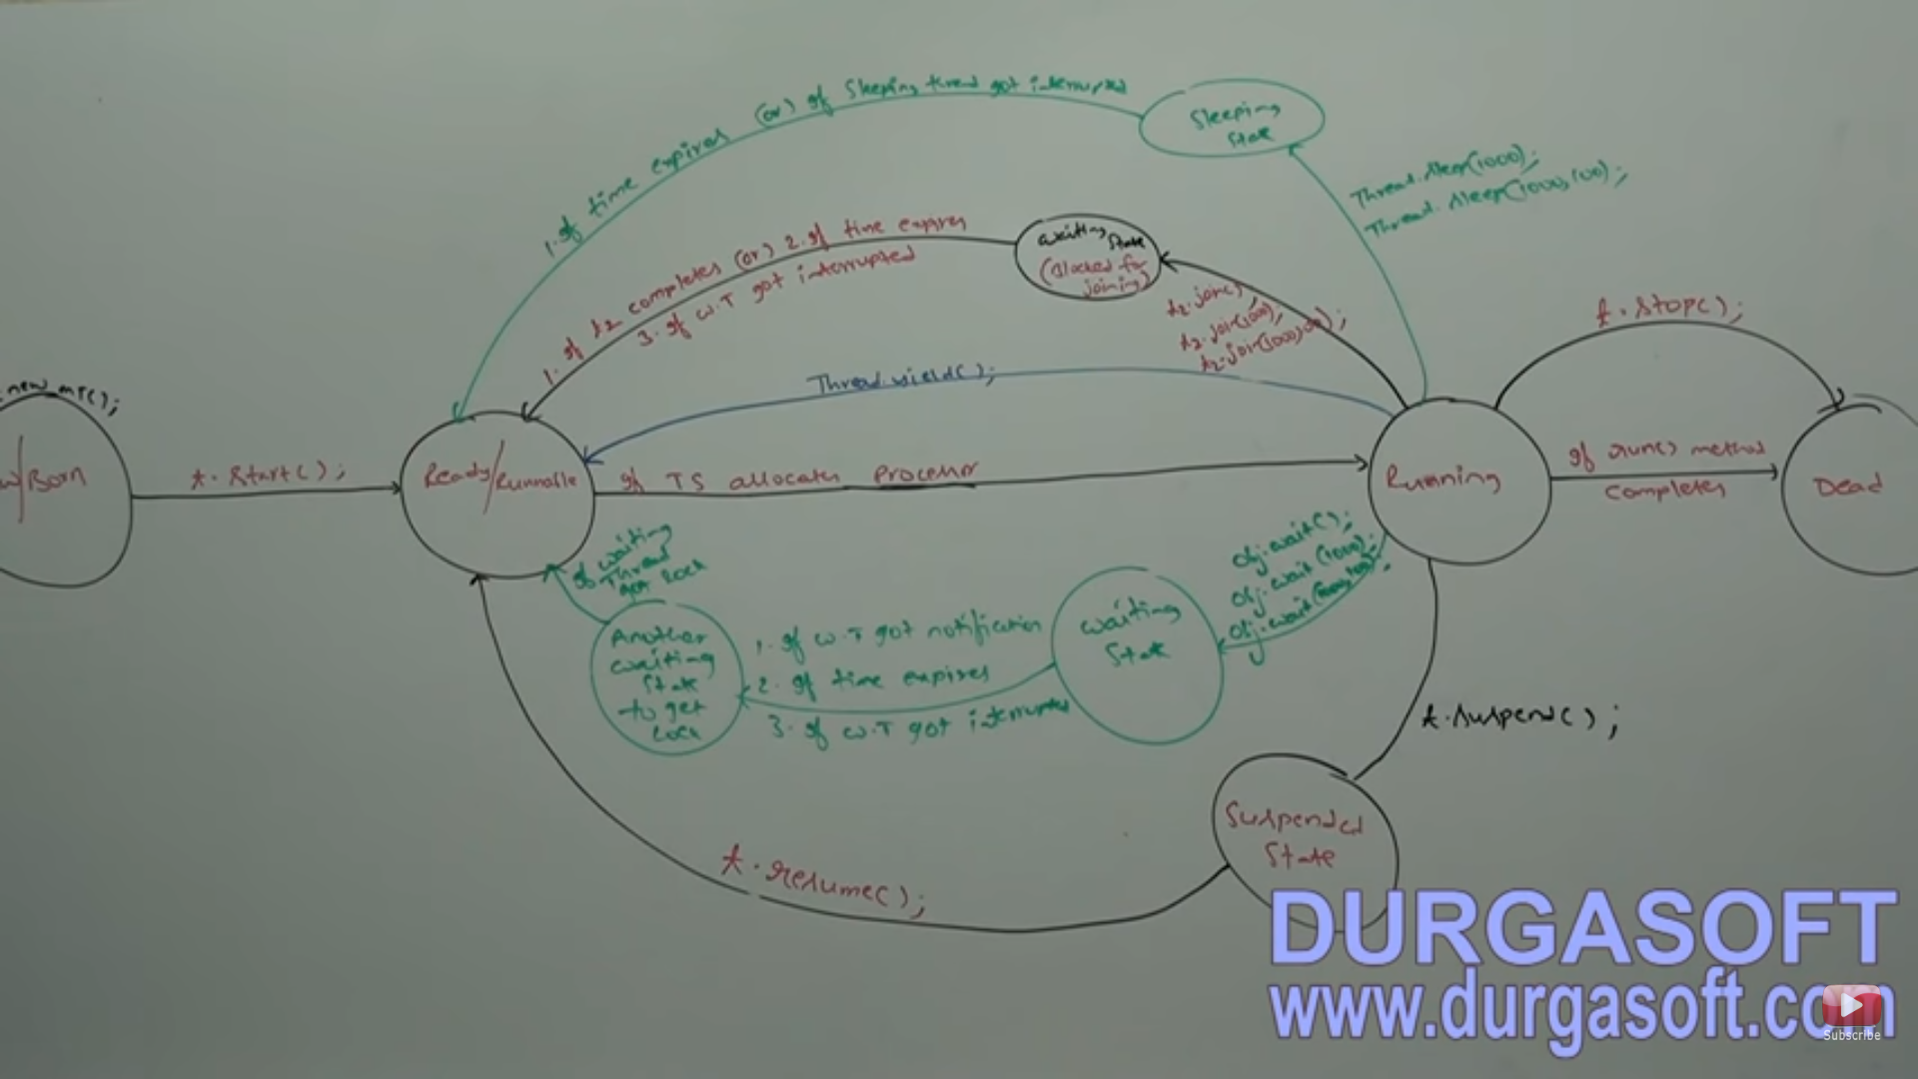

**ADVANCED MULTITHREADING CONCEPTS:**

**THREADGROUP:**

* Based on the functionality we can group threads into single unit known as ThreadGroup, which provides the flexibility for doing the common operations on the entire group very easily. For example, we can set the MAX priority for all the threads in the thread group.
* A threadgroup can contain sub threadgroups also.
* Every thread in java belongs to some thread group.
* Main thread belongs to Main ThreadGroup.
* Every threadgroup in java is child group of parent group called system group directly or indirectly. System group acts as root threadgroup for all threadgroups in java.
* System group contains system level threads. Below are few
  + **Finalizer (Garbage Collector)**
  + **Reference Handler**
  + **Signal Dispatcher**
  + **Attach Listener.**
* Main threadgroup is direct child threadgroup of System threadgroup.
* Please refer ThreadGroupDemo.java for details on how to get the threadgroupname and threadgroup parent also.
* ThreadGroup is java class available in the java.lang package.
* ThreadGroup is direct subclass of Object class.
* Below are the constructors in the ThreadGroup class:
  + ThreadGroup(String name); creates with specified name.
    - ThreadGroup g=new ThreadGroup(“My Group”); The parent group of the above declared group is the thread group which executes it. Here in our scenario it is main thread group. Refer ThreadGroupDemo.java
  + ThreadGroup(ThreadGroup parentgroupname, String name); This constructor provides the flexibility of defining the parent group for our threadgroup and name to our threadgroup.
    - ThreadGroup g1=new ThreadGroup(g, “My Second Group”); Refer ThreadGroupDemo.java
* Important methods of the ThreadGroup class:
  + String getName()- This method returns the name of the threadgroup.
  + Int getMaxPriority()- Returns the max priority of the ThreadGroup. By default maximum priority of the ThreadGroup is 10.
  + void setMaxPriority(int maxPriority)- Sets the max priority for the ThreadGroup. If we set the low max priority for the threadgroup than the thread priorities which is already there in the threadgroup, then the threads already there in the threadgroup will not have any impact only the new added threads will have the impact by default it will be changed to the max priority of the threadgroup. Please refer ThreadGroupPriorities.java.
  + ThreadGroup getParent()- Returns parent group of the current thread group.
  + void list()- Prints the complete information about the threadgroup to the console.
  + int activeCount() – Returns the approximate active count of the threads in the current thread group.
  + int activeGroupCount() – Returns the active count of the sub threadgroup in the current threadgroup.
  + int enumerate(Thread[] t)- Copies all the active threads in the current threadgroup and its sub group to the Thread array.
  + Int enumerate(ThreadGroup[] g)- Copies all the active sub groups to the ThreadGroup[] g.
  + boolean isDaemon()- Checks whether current thread group is Daemon or not.
  + void setDaemon(boolean d)- sets the daemon nature to the current threadgroup.
  + void interrupt()- interrupts all the waiting threads in the current thread group.
  + Void destroy()- destroys all the sub threadgroups and threads in the current threadgroup.
* Active threads means here which are currently executing or the threads which are in sleeping or waiting state.

**JAVA.UTIL.CONCURRENT PACKAGE:**

PROBLEMS WITH TRADITIONAL SYNCHRONIZED KEYWORD:

* Suppose if there are two threads t1 and t2, t1 got the object lock and it is executing the synchronized area, in traditional synchronization t2 has to wait till it gets the lock of the object without doing alternate operations. Hence performance is degraded here in this case.
* There is no flexibility to provide maximum waiting time for thread for the lock in traditional synchronization which may create performance problems and cause the deadlock.
* If a thread releases the lock, then there is no guarantee that which waiting thread will get the lock in traditional synchronization. There is no transparency in this case.
* There is no api which can list all the waiting threads for a lock.
* Synchronized keyword can be used only for methods and blocks. It is not applicable across the multiple methods. Whereas wrt to java.util.concurrent.locks package provides the flexibility across the methods.
* To overcome all the above problems with traditional synchronization sun people has introduced the java.util.concurrent.locks package in 1.5 version of java.
* It also provides several enhancements to the programmer to make effective utilization for the concurrency.

LOCK Interface in java.util.concurrent.locks.Lock:

* It is also similar to the implicit lock acquired for executing the synchronized area. But Lock implementations provide extensive features for the concurrency than traditional implicit locks.
* Important methods in the LOCK interface:
  + void lock(): This method is used for getting the lock of a particular object for the current thread. If lock is available then current thread will get it immediately. Otherwise current thread will wait till it gets the lock. This method functionality is same as the synchronized keyword.
  + boolean tryLock(): This method is for the purpose of trying for a lock without waiting. If lock is available then thread acquires the lock and returns true and performs safe operations otherwise if that method returns false then perform alternative operations without waiting. In this case thread will never enter into the waiting state.
    - Ex: if(l.tryLock()){

then perform safe operations} else{ perform alternative operations}.

* + boolean tryLock(long time, TimeUnit unit): This method tries for the lock, if lock is available then proceed with safe operations. If lock is not available then wait for the specified amount of time in the method parameter. Here TimeUnit is an enum which contains the grouped constants like NANOSECONDS, MICROSECONDS, MILLISECONDS, SECONDS, MINUTES, HOURS AND DAYS and is present in the java.util.concurrent package.
    - Ex: if(l.tryLock(1000, TimeUnit.MILLISECONDS)){}
  + void lockInterruptibly(): This method checks for the lock, if lock is available then the current thread will get the lock and will proceed with the safe operations. Otherwise the current thread will wait for lock if the waiting thread does not get interrupted. If the waiting thread is interrupted then it will not get a lock.
  + void unlock(): This method is for the purpose of releasing the lock. If a thread has to call the unlock() then that thread should be the owner of the lock otherwise we will get RunTimeException named: IllegalMonitorStateExecption. For Ex: If a thread calls directly t.unlock() before it has acquired lock then we will get IllegalMonitorStateException.
* ReentrantLock class: This class has provided the implementation for the Lock interface and direct child class of Object class. And below are the important methods in this class.
* Meaning of Reentrant here is like: A thread can get the same lock again and again once a thread gets the lock JVM internally increments the hold count to 1 from 0. A lock can be requested any number of times and internally hold count will be increased when we call lock() every time and hold count will be reduced every time we call unlock(). Once the thread hold count reaches 0 then the thread is going to release the lock.
  + ReentrantLock lock=new ReentrantLock();
* Constructors inside the ReentrantLock class:
  + ReentrantLock lock=new ReentrantLock(); creates the instance of the Reentrant lock.
  + Reentrant lock=new ReentrantLock(boolean fairness); creates reentrant lock with specified fairness. If fairness value is true then the longest waiting thread(FCFS algm is used) is going to get the lock. By default fairness value is false then which thread is going to get the lock we cannot predict.
* Methods in the Reentrant class:
  + Since this class implements Lock interface by default all the methods in the Lock interface has to provide implementation in the ReentrantLock class. Below are the 5 methods in the Lock interface:
  + void lock()
  + boolean tryLock()
  + boolean tryLock(long time, TimeUnit unit)
  + void lockInterruptibly()
  + void unlock()
  + int getHoldCount()- This method returns the number of holds by the current thread.
  + boolean isHeldByCurrentThread()- This method returns true if lock is with the current thread.
  + int getQueueLength()- Returns the count of the threads in the queue.
  + Collection getQueuedThreads()- Returns all the queued threads for the lock.
  + boolean hasQueuedThreads()- This method returns true if there are queued threads or any thread waiting for the lock.
  + boolean isLocked()- Returns true if the lock is assigned to some thread.
  + boolean isFair()- Returns true if the fairness policy is set to true value.
  + Thread getOwner()- Returns the thread which acquires the lock.
  + Refer ReentrantLockDemo2.java where we have used ReentrantLock concept instead of synchronized to get the data consistency.
* Once we call the l.lock() then we should call the l.unlock() otherwise remaining threads will not be able to get the lock of the object and other threads has to wait indefinitely.
* Please refer ReentrantLockDemo3.java for tryLock() demo where threads will not wait anymore if lock is not available and performs the alternative operations.
* Please refer ReentrantLockDemo4.java for tryLock() demo with specified time period where threads will wait for some time specified and tries again till that thread gets the lock.
* Once we are aware of the Lock and ReentrantLock concepts then it is not at all recommended to use the synchronized keyword as we are getting more flexibilities with java.util.concurrent.lock package.